Audio MCU Development Board Specification

- OVERVIEW
The Audio MCU Development Board is a custom embedded hardware platform intended for real-time audio and guitar-effects development.
The board will combine a microcontroller, analog audio input/output circuitry, ADC/DAC conversion, power regulation, and USB programming/debug capability onto a single PCB. The primary goal is to create a reuseable and convenient platform for experimenting with digital audio processing.
The board should accept a standard ¼ inch instrument-level input, convert the signal into a form suitable for digital processing by the MCU, and reconstruct an analog signal at a ¼ inch output.
- PRIMARY DESIGN GOALS

- Accept a standard guitar/instrument signal through a 1/4 inch TS input.
- Present a high input impedance appropriate for passive guitar pickups
- Protect the analog front end and ADC from ESD, transients, and signals outside the allowable voltage range.
- Provide analog buffering and appropriate gain before conversion.
- Bias bipolar audio appropriately for a single-supply ADC.
- Provide analog anti-alias filtering.
- Digitize audio at a rate and resolution appropriate for guitar/audio DSP.
- Process audio in real time using an onboard MCU.
- Convert processed audio back to analog.
- Filter and buffer the analog output.
- Provide a standard ¼ inch TS output.
- Operate from a conventional 9v pedal-style DC supply.
- Provide onboard regulation for analog and digital supply rails.
- Support programming/debugging through USB.
- Expose useful MCU pins for experimentation/expansion
- Provide basic user controls such as potentiometers, switches, buttons, LEDs, etc.

- SPECIFICATIONS
- Audio input: 1 x mono ¼” TS
- Audio output: 1 x mono ¼” TS
- Input impedance: > 1M
- Nominal Source: Guitar/Instrument
- Sample Rate: 48 kHz
- ADC resolution: 16 – 24 bit
- Audio Bandwidth: 20 – 20kHz
- Processing: Real time, low latency
- Main power Input: 9v DC
- Programming: USB
- Debug: SWD/JTAG as appropriate
- Expansion: GPIO/SPI/I2C/UART/Analog
- PCB: Custom MCU and analog circuity, 4 layer preferred

3. SYSTEM DIAGRAM
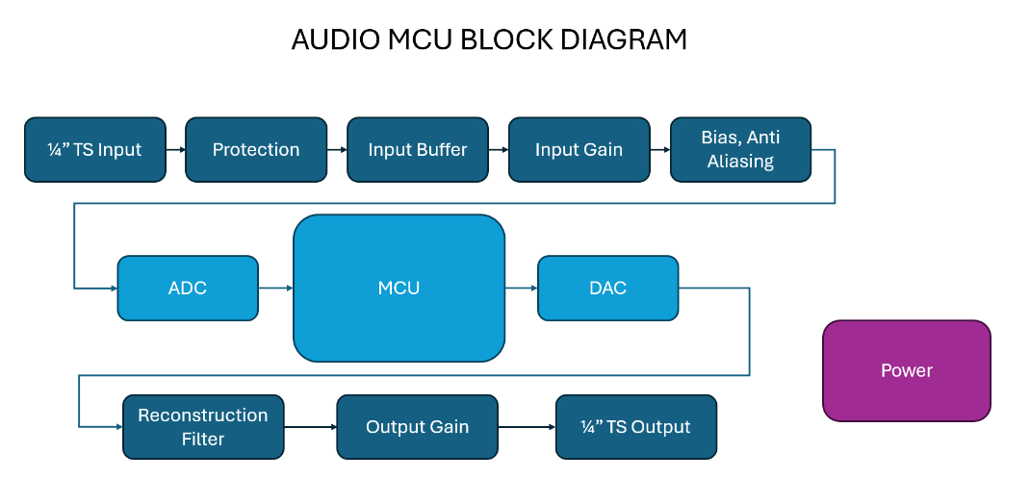

- SCHEMATIC LAYOUT
